Version: | v1
Date: | 22/02/2018
Smart Metering Implementation Programme (SMIP)

Device Integration Test Approach
Release 2.0

Contents
1 Introduction 3
1.1 Approval and Governance 4
1.2 Definition of Terms 4
1.3 Objective of Document 4
1.4 Scope of Document 6
1.5 Audience 7
1.6 RAID 7
1.6.1 Risks 7
1.6.2 Assumptions 9
1.6.3 Issues 9
1.6.4 Dependencies 9
2 Device Selection 10
3 DIT Procedure 10
3.1 Entry Criteria 10
3.2 Environment 11
3.3 Test Set Up 13
3.4 Tools 13
3.5 Data requirements 13
3.5.1 CSP 13
3.5.2 Device Manufacturers 14
3.6 Resources Required 15
3.7 Suspension Criteria and Resumption Requirement 16
3.7.1 Exit Criteria 16
3.7.2 Defect Mask 18
4 Testing Issue Management 19
5 Manufacturer Support Requirements 19
5.1 Installation & Commissioning 20
5.2 Firmware Upgrades 20
Appendix A – Test Plan 21
Appendix B – RASCI 22
Appendix C – CSP Lab Set Up 23
Appendix D – Plan on Page 27

Introduction
The DCC shall ensure that Device Integration Testing (DIT) is carried out in accordance with the provisions of this document and the SEC Variation Testing Approach Document for Release 2.0.
DIT will test the interoperability between the Modified DCC Total System and:
- new CHTS v1.1 Communications Hubs (single and Dual band);
- Communications Hubs that have been upgraded from CHTS v1.0 to CHTS v1.1;
- existing CHTS v1.0 Communications Hubs, prior to upgrade;
- devices that form part of enrolled Smart Metering Systems and associated IHDs; and
- new devices complying with the latest version of SMETS (where suitable sub GHz devices are available to support testing)
DIT will have dependencies on SIT and PIT as described in section 1.6.4 Table 4 DIT Issues
Dependencies but will take place almost independently of other phases, and will be subject to the overall LC13 plan. DCC will make use of the service user simulator tool developed for previous releases, to interact with Communications Hubs and devices.
DIT is not a "time boxed" activity in that it only finishes once the Exit Criteria are met or DCC has confirmed with SEC Panel Testing Advisory Group for any relaxation of the exit criteria.
DIT as a phase will build upon the lessons learnt from Release R1.2 and R1.3 where the use of Devices in testing as planned was not practical. The deliverables for this test phase shall acknowledge the potential availability risk of suitable Devices and make exceptional provision for DIT to be undertaken using testing stubs.
DIT will provide industry with confidence that DCC systems upgraded to R2.0 - v1.0, v1.1 Communications Hubs, and v1.0 Communications Hubs upgraded to v1.1 interoperate with existing SMETS2 v2.0 Devices (including IHDs) and Devices designed to meet SMETS2 v3.0. DIT will also include the testing of upgraded devices from SMETS2 v2.0 to SMETS2 v3.0.
If the availability of sufficient capable and supported devices, particularly sub GHz devices, would result in any of the requirements below being at risk of not being proven, DCC will, subject to the consent of the Secretary of State, complete such testing and exit DIT as is practical, using emulators if required, and provide detail of the reasons why DIT has not been fully completed in the Test Phase Completion report.
Any decision not to use sub GHz devices will be communicated, with supporting evidence, in a timely fashion to BEIS for discussion.
Where suitable Devices become available within the UIT Test Phase of Release 2.0, subject to available time, DCC will endeavour to test the elements previously completed with emulators using real Devices.
DIT will take a risk based approach to the scope of testing undertaken and use a variety of devices and firmware releases to maximise the benefits of testing in the timescales available.

Approval and Governance
This document reflects the content of the Release 2.0 Testing Approach Document, which was subject to consultation. It has been developed by DCC and reviewed with the SEC Panel Testing Advisory Group and BEIS.
DCC will submit the final version to the SEC Panel Testing Advisory Group for consideration of a recommendation to SEC Panel, who in turn will make a recommendation to the Secretary of State.

Definition of Terms
This document uses standard testing terminology, and definitions relevant to the Smart Energy Code are as defined in Section A (Definitions and Interpretations) of the SEC. Other terms will be as defined in the Testing Approach Document for Release 2.0, or within the body of the document itself.

Objective of Document
The objective of this document is to describe the activities associated with the planning, operation, exiting and reporting of the DIT test phase.
The document should be detailed enough to allow the DCC and its service providers to plan and execute DIT. Therefore, providing DCC with the assurance that devices will interact with the systems as designed.
The DIT requirements are described in Table 1
All the requirements in Table 1 are subject to the availability of sufficient individual devices, capable of fully participating in the testing at the time of the planned activity and supported by the manufacturers of those devices. The table is taken from the Testing Approach Document for Release 2.0. All devices will be tested with the combinations of Communications Hubs and DSP systems shown in Table 2: Release Baseline Matrix.
Ref | Requirement
DIT.1 | DIT shall test DCC Communications Hubs with a minimum of 2 ESME Devices from different manufacturers designed to meet SMETS v3.0
DIT.2 | DIT shall test DCC Communications Hubs with a minimum of 2 GSME Devices from different manufacturers designed to meet SMETS v3.0
DIT.3 | DIT shall test DCC Communications Hubs with a minimum of 2 GSME Devices from different manufacturers designed to meet SMETS2 v3.0 and capable of Sub GHz HAN communications
DIT.4 | DIT shall test DCC Communications Hubs with a minimum of 2 PPMID Devices from different manufacturers designed to meet SMETS2 v3.0
DIT.5 | DIT shall test DCC Communications Hubs with a minimum of 2 PPMID Devices from different manufacturers designed to meet SMETS2 v3.0 and capable of Sub GHz communications
DIT.6 | DIT shall test DCC Communications Hubs with a minimum of one Device for each of the leading ZigBee silicon stack providers
DIT.7 | DCC shall select Devices for DIT using dry-run qualification events and commercial support proposals
DIT.8 | DIT shall specifically ensure that DCC Communications Hubs are verified as capable of complying with:  - GBCS v2.0 10.6.2.6 – Frequency Agility  - GBCS v2.0 10.6.2.2 – Duty Cycle Monitoring
DIT.9 | DIT shall include risk based regression testing of DCC Communications Hubs with a minimum of 2 SMETS2 v2.0 ESME and GSME Devices selected to be representative of a significant proportion of the installed base of SMETS2 v2.0 Devices at the time of undertaking DIT
DIT.10 | Should actual HCALCS Devices exist and be in a suitable state of readiness, DIT shall test DCC Communications Hubs with a minimum of 1 HCALCS Device.
DIT.11 | DIT will include defined non-functional testing, limited to message and response timings across home area networks for both HAN radio frequencies
DIT.12 | DIT shall test DCC Communications Hubs with a minimum of 2 IHD Devices from different manufacturers
DIT.13 | DIT shall include end to end testing of the Local Command Interface using hand held terminal devices, if available, or using the DCC tool required to be developed for testing in SIT
DIT.14 | DIT shall include regression testing of v1.0 Communications Hubs against devices designed to meet SMETS2 v3.0
DIT.15 | DIT shall include regression testing of SMETS2 v2.0 meter with R2.0 of DSP.

Table 1: DIT Requirements
To clarify DIT.9 – this will ensure that the introduction of v1.1 Communications Hubs that operate to ZigBee 1.4 are compatible with existing Devices that operate to ZigBee 1.2a. DIT will include testing to demonstrate that Devices operating to ZigBee 1.2a are not impacted by;
- Communications Hubs being upgraded from v1.0 to v1.1 while 1.2a Devices are connected
- Communications Hubs being upgraded from v1.0 to v1.1 and a new 1.2a Device subsequently being connected
- v1.1 Communications Hubs being installed and connected to 1.2a Devices

Scope of Document
The document will cover activities associated with the DIT test stage, specifically,
- Environment preparation
- Device selection
- Device preparation (actual devices and associated data)
  - Communications Hubs (Single and Dual band)
  - Electricity smart meters
  - Gas smart meters
  - In home displays
  - Prepayment interface devices
  - Customer access device
  - Hand held terminal.
  - Han connected auxiliary load control switch
- Resources from
  - CSPs
  - DSP
  - SI
  - DCC
  - Device manufactures
- Issue management and resolution
- Reporting
  - Issues
  - Progress

Audience
The audience for this document is DCC and its service providers. BEIS and the SEC Panel Technical Advisory Group will also have visibility of this document and will review the content.
This document will ultimately be made publicly available on the DCC external website.

RAID

Risks
Reference | Description | Mitigation
DIT.R.01 | No/insufficient devices are available for testing that are SMETS2 v3.0 compliant | Selection criteria could be relaxed – with approval from SEC Panel Testing Advisory Group
DIT.R.02 | Devices fail the selection criteria | Selection criteria could be relaxed – with approval from SEC Panel Testing Advisory Group
DIT.R.03 | Resources from DCC SPs are unavailable. | DCC internal change request for Service Provider resource has been submitted in a timely manner and resources are confirmed
DIT.R.04 | Defects in DCC systems stops testing in DIT | Defects will be address and fixed in line with the target response times defined in the test issue management process
DIT.R.05 | Defect on devices blocks testing | Commercial contracts in place to ensure device manufactures fix defects in line with the test issues management process
DIT.R.06 | Testing takes longer than time allowed to cover all the scope. | Project management of testing to ensure adequate reporting and progress monitoring
DIT.R.07 | Availability of CHTS v1.1 Communications Hub on time will impact DIT testing | CHTS v1.1 Communications Hubs are planned to be ready for DIT. Regression testing can be performed first on CHTS v1.0 Communications Hubs until devices are available
DIT.R.08 | Issue related to CHTS v1.1 operation of Communications Hub impact testing | CSPs are contracted to fix defects in line with the testing issues management process
DIT.R.09 | Limitation of the service user simulator | Risk will be removed as the service user simulator has been found to be fit for purpose. Should an issue be found then a “fix on fail” approach for the service user simulator will be taken.
DIT.R.10 | Delay in ZigBee certification of CHTS v1.1 Devices | ZigBee certification is only required at DIT exit so time is available to address any issues found during the certification period.
DIT.R.11 | Communications Hubs will not be ZigBee certified at the start of DIT, there is a potential that they will not form or maintain a HAN. | CSPs are being monitored on their implementation of R2.0. DCC will decide on when and what to test based on the progress made by CSPs on their certification.
DIT.R.12 | All meter types become blocked and therefore suspended from testing and DIT can’t proceed until fixes are available. | Replan in line with the fix time provided by the device manufacturers. Commercial contracts are in place for fixes to be deployed.
Table 2 DIT Risks

Assumptions
Reference | Description
DIT.A.01 | DIT scope is for DSP to be R2.0 with SMETS2 v2.0 devices and CHTS v1.1 communications hubs. In addition, SMETS2 devices, CHTS v1.0 Communications Hubs and DSP R2.0.
DIT.A.02 | GBCS v2.0 devices will be available for DIT*
DIT.A.03 | All Devices (including communications hubs) at the start of DIT will be compliant with DCC release 1.3, not 1.2
DIT.A.04 | 2 x ESME and 2 x GSME will be selected from at least 2 manufactures.
DIT.A.05 | Will also include CHF, GPF, HCALCS, PPMID, IHD but in a ‘mixed economy’, not every combination.
DIT.A.06 | Approximately 70 unique scenarios (per CHF) with an average of 10 service requests
DIT.A.07 | Critical alerts will be tested, see test plan
DIT.A.08 | The SITB environment will be used for testing
DIT.A.09 | CGI’s service user simulator will be used to send service requests to the devices.
DIT.A.10 | The relevant expertise from device manufactures, DCC and its service providers will be available to support testing
DIT.A.11 | The timescales for DIT are as indicated in the plan on a page shown in Appendix D –
Table 3 DIT Assumptions
*Should GBCS 2.0 device not be available for DIT then the approach will be revised to reflect the position.

Issues
Reference | Description
DIT.I.01 | No commercial cover for support from device manufacturers.
Table 4 DIT Issues

Dependencies
Reference | Description
DIT.D.01 | DCC systems are ready and the environments are working
DIT.D.02 | Tools to generate and send commands to end device are functioning and reliable
DIT.D.03 | All device data provided by the manufacturers is correct
DIT.D.04 | No issues seen in SIT that could impact DIT
DIT.D.05 | No issues seen in PIT for either CSP that could impact DIT
DIT.D.06 | Latest Communications Hub firmware being available
DIT.D.07 | Latest DSP release available
DIT.D.08 | All resources are available to support DIT
DIT.D.09 | ALM is configured correctly
DIT.D.10 | Device selection is complete, and all selection criteria is met
DIT.D.11 | Formal DCC DIT gate entry has been completed
Table 5 DIT Dependencies

Device Selection
DCC has selected meters and IHD/PPMIDs for use in DIT. The methodology and criteria used in the selection process is described in the DCC document Device Integration Testing selection activity.
Where, prior to the coming into effect of this Device Integration Testing Approach Document by virtue of its approval by the Secretary of State pursuant to section 8 of the SEC Variation Testing Approach Document for Release 2.0, the DCC has selected meters and/or IHDs/PPMIDs for use in DIT in accordance with the methodology and criteria described in the Device Integration Testing selection activity section of this document, the selections made by the DCC shall be as selections made and having effect under this document on the date on which it comes into effect.

DIT Procedure

Entry Criteria
To enter DIT there are a number of prerequisites that are either met or have an appropriate workaround in place.
Reference | Criteria | Evidence Required
DIT.EN.1 | The formal DCC entry gate for DIT has been completed (see dependencies 0, DIT.D.11) | Minutes of DCC DIT entry gate
DIT.EN.2 | No issues have been identified in R2.0 SIT/PIT that impact the testing in DIT (see dependencies 0, DIT.D.04 and DIT.D.05) | Confirmation from Programme Team that work off plans presented to PIT test assurance boards, and current SIT issues, do not impact start of DIT
DIT.EN.3 | DCC has completed device selection and devices are available, or DCC has the approval from DCC/Industry/BEIS to be able to commence DIT with emulators | Commercial arrangements with Device providers  Devices available in DCC DIT location
DIT.EN.4 | DSP PIT testing has successfully completed | Test assurance board completion certificate for DSP PIT for R2.0
DIT.EN.5 | Environments have been successfully upgraded to the latest DSP release to support GBCS 2.0 as agreed at the DCC formal gate entry into DIT | Confirmed from DCC DIT entry gate minutes
DIT.EN.6 | SIT entry gate for Release 2.0 has been passed | Evidence from SI of successful start of SIT and readiness of suitable resources and environments to support DIT
Table 6 DIT Entry Criteria

Environment
The testing environment to be used to perform DIT must be able to support all the generation, sending and delivery of the DUIS service requests and alerts in scope of DIT.
The service user simulator will be able to simultaneously test devices that share a common HAN.
Downtime of the environment will be kept to out of hours unless prior agreement is reached or the fix of a system blocking defect is required to continue testing. An essential security upgrade/fix would also justify suspension of testing.
The DSP and CSP (including Communications Hubs) must be using the most recent baseline release of code/firmware. This must be the same as what is being testing in SIT.
DIT must test environment scenarios that simulate the possible states of the live environment of the smart meter roll out. Table 7 shows the potential scenarios that could be seen. These must be regression tested to ensure the systems will work together before and after the upgrading of the different parts of the whole system. Functional testing will also be performed on the scenarios shown in the table.
R1.3 represents compliance with GBCS 1.0 and associated technical documentation as defined in TSG1 and was the first go live baseline of DCC systems.
R2.0 is the release of system code as defined by TSG2 and shows compliance with GBCS 2.0 and other associated documents and will be the second uplift to the live environment.
SMETS is the standard to which the meters are built to.

Service User | DSP/CSP | CHs | Meters | Regression Testing
R1.3 | R1.3 | CHTS v1.0 | SMETS2 v2.0 | Not required as is current baseline
R1.3 | R2.0 | CHTS v1.0 | SMETS2 v2.0 | Required
R1.3 | R2.0 | v1.1 CH’s | SMETS2 v2.0 | Required
R2.0 | R2.0 | CHTS v1.0 | SMETS2 v2.0 | Required*
R2.0 | R2.0 | v1.1 CH’s | SMETS2 v2.0 | Required
R2.0 | R2.0 | v1.1 CH’s | SMETS2 v3.0 | Required
Table 7 Release Baseline Matrix
*The upgrade from a communication Hub on R1.3 to R2.0 should be tested as this will be a high priority in the live environment.
Devices used in the environment must all be approved at the change release board (CRB) and must be configured as new device. I.E. SMKI organisational certificates must contain ACB certificates in the supplier trust anchor cells, as per the OCA4 SMKI pack.
All devices will use ZigBee test certificates
All SMKI certificates used will be from the SIT configuration.
All devices will be recorded in the Device Asset Library (DAL).
Communications Hubs
If re-using a Communications Hub in any test set it must not be associated with any previous devices so the CSPs and SI must check the DSP database for associations that are present. The Communications Hubs should be consistently de-commissioned in the DSP environment to minimise the need for manually re-flashing of Communications Hubs.

Meters
Meters must also be configured as new. They must have the correct SIT SMKI test certificates installed and checked by SI prior to testing.
Should meters need to be de-commissioned this should be done in a consistent manner in the DSP environment to minimise the need for a manual clear down of meters.
Meters that are compliant with SMETS2 v3.0/GBCS v2.0 must be backwards compatible with the SMETS2 v2.0/GBCS 1.0 devices.

Test Set Up
The HP ALM system must be preconfigured in line with the test lab set up and the scope of tests to be performed. Data items must also be configured to allow for reporting of progress and issues seen.

Tools
Data logging must be available for issue management and resolution at the DSP and CSPs. ZigBee sniffer devices must be utilised for HAN level communications in the labs.
As stated above, The SI’s HP ALM will be used for testing process set up and issue management.
Other tools that are used could include,
- File signing tool
- UTRN generator
- TRT decoding utility (triage purposes)
- Ferret tool for monitoring motorway traffic
- Service user simulator(s)

Data requirements
All device data specified in the following sections must be recorded in the DAL prior to testing.

CSP
The CSPs must provide the details of each Communications Hubs they are providing for DIT testing. The specific data items required by the SI are:
- CHF: GUID
- GPF: GUID
- Firmware version
- FlexNet ID (CSP N only)

Device Manufacturers
Device manufacturers must provide the following information prior to starting testing. This information is required for each device supplied.
- GUID
- ZigBee installation code
- SMKI device certificate Signing Requests to generate the Device Certificates (serial numbers for digital signature and key agreement)
- Firmware version number
- Confirmation of,
  - ZigBee test certificates installed
  - OCA4 organisational certificates installed.
- CPL documentation
- Release notes

Resources Required
Table 8: Task Allocation shows the high-level tasks which are involved in the selection and operation of device integration. The table does not show the resources required, simply the task required. It is up to the specific roles to allocate the appropriate resource to the task.
Task | SI | DSP | CSP CS | CSP N | Device M’facturer | DCC | BEIS | SEC Panel (TAG)
Device Selection
Planning | x |  | x | x |  | x | x
Running tests |  |  | x | x | x
Capturing logs |  |  | x | x | x
Assessing results | x |  | x | x | x | x
Communicating results |  |  |  |  |  | x
DIT
Planning | x |  | x | x | x | x | x
Preparation of devices (including data) | x | x | x | x | x | x
Preparation of the environments | x | x | x | x
Performing tests | x |  | x | x | x
Collecting logs | x | x | x | x | x
Triage | x | x | x | x | x | x
Reporting of issues | x |  |  |  |  | x
Reporting of progress | x |  |  |  |  | x
Reporting to programme | x |  |  |  |  | x
Reporting to industry |  |  |  |  |  | x | x
Completion of Test Phase | x |  |  |  |  | x | x | x
Table 8: Task Allocation

Suspension Criteria and Resumption Requirement
In the event where any device (excluding Communications Hubs) is found to be in a state where the testing can no longer be performed then the device will become suspended. This can happen in the follow conditions
- The install and commission process has failed and after triage the issue is found to be on the device.
- Device is unable to be placed in the correct mode of operation (credit or prepayment) to proceed with the testing.
- Device is physically damaged and dangerous to work on
- Device becomes “bricked” or “frozen” where no response from any service request is obtained and communications are not possible.
Resumption of testing can commence once a fix has been identified and approved by the DCC change release board. However, if no fix is available then the device may be taken out of scope of DIT on the approval of DCC.
Should all meters become suspended at the same time then DIT will be suspended until a fix is implemented (see 1.6.1, DIT.R.12). DCC may seek to select Devices from different manufacturers to support the completion of DIT, a decision that will need to consider time elapsed and remaining, likelihood and availability of suitable devices, and progress through the test plan.
Device Manufacturers who are selected by DCC to participate in DIT will enter into a commercial agreement to fix defects within timescales defined in section 11 of the Testing Approach Document for Release 2.0. Failure to adhere to these timescales will result in formal escalations between DCC and the associated device manufactures. This applies to all devices supplied under the agreements.

Exit Criteria
The objectives of DIT are to test the modified DCC total system with enrolled devices and those that are compliant with SMETS2 v2.0 & SMETS2 v3.0.
On the completion of DIT, a test completion report will be produced and presented to the DCC test assurance board for approval and to SEC Panel Testing Advisory Group to provide a recommendation to the SEC Panel.
The success/exit criteria for DIT are shown below. Note that defects and testing issues raised against selected Devices for DIT do not count towards the DCC defect mask.
Reference | Criteria | Evidence Required
DIT.EX.1 | At least one ESME, GSME and IHD/PPMID that have been selected to participate in DIT successfully completes all planned regression testing | Test phase completion report and DCC test assurance board completion certificate
DIT.EX.2 | Regression testing has been executed on each communication hub variant with all selected devices | Test phase completion report and DCC test assurance board completion certificate
DIT.EX.3 | For single band functional testing;  All planned tests per Communications Hub variant have been executed against all selected devices; and  100% pass rate on each Communications Hub variant for all the planned tests by testing any combination of the selected devices | Test phase completion report and DCC test assurance board completion certificate
DIT.EX.4 | There are no open defects against the DCC code base outside of the defect mask | Test phase completion report and DCC test assurance board completion certificate
DIT.EX.5 | For dual band functional testing:  All planned tests per Communications Hub variant have been executed against all selected devices, provided that in the absence of any suitable devices and subject to the consent of the Secretary of State, DCC may complete testing without using actual devices and;  A minimum of 85% of the completed tests have passed for non-business critical scenarios  All business-critical scenarios must achieve 100% pass. | Test phase completion report and DCC test assurance board completion certificate
DIT.EX.6 | All defects recorded in ALM against the DIT Testing Phase are covered by an agreed and documented work off plan, subject to the requirements of the DIT defect mask as described below | Test phase completion report and DCC test assurance board completion certificate
DIT.EX.7 | Subject to the availability of devices for testing, Install and Commission and firmware upgrades must have been completed on all SiLabs and NPX meter/Communications Hub combinations | Test phase completion report
DIT.EX.8 | Test results have been document and evidence captured | Test phase completion report
DIT.EX.9 | A complete set of test issue logs have been produced | Present in ALM
DIT.EX.10 | Full test traceability to the test plan has been documented | Test phase completion report
DIT.EX.11 | Test phase completion report produced | Approval by DCC test assurance board
DIT.EX.12 | A test phase completion certificate for DIT has been issued by DCC test assurance board | Certificate
Table 9 DIT Exit Criteria

Defect Mask
The following table lists the standard target thresholds for outstanding test issues in DIT phase, as defined in the Service Provider contracts. This table is a variation of the tables in the Testing Approach Document for Release 2.0 and the data for DIT remains consistent with the Testing Approach Document.
Selected devices (ESME, GSME and IHD/PPMID) are not included in this defect mask. The manufactures will endeavour to fix defects as part of the commercial contract undertaken with DCC.
Any outstanding issues on devices will be reported as part of the test completion.
Test Issue Severity | 1 | 2 | 3 | 4 | 5
Number of outstanding Issues | 0 | 0 | 15 | 30 | 60
Work Off Plan Timescales (working days from Quality Gate Meeting) | n/a | n/a | 20 | 40 | 60
Table 10 Defect Mask and Work Off Timescales
Note that:
- These figures are per Service Provider, i.e. 15 Severity 3s for the DSP, 15 for CSP N and 15 for CSP C/S
- The defect masks shall include any security defects within the relevant testing phase
- the DCC test assurance board, including industry representatives, may judge that the DIT Test Phase is complete if the target thresholds set in the Exit Criteria for the Test Phase Plan have not been achieved, provided that an agreed work off plan is in place
- If the DCC test assurance board, including industry representatives, believes that an exception for a Severity 2 issue at DIT exit should be considered, DCC will request an ex-committee review by the SEC Panel Testing Advisory Group before confirming DCC proposal to exit DIT, which would remain subject to SEC Panel agreement

Testing Issue Management
Testing issue management for DIT shall follow the requirements of section 11 of the Testing Approach Document for Release 2.0, with the following additional item:
- Should a device manufacturer wish to raise a defect they must complete the relevant form (DCC to provide on request) and then submit the form the SI to complete an entry in HP ALM. DCC will communicate back to the device manufacturer the defect number and the status.

Manufacturer Support Requirements
Commercial agreements must be agreed and signed with the selected device manufactures for them to provide support into DIT. The contents of the agreements must include:
- Device manufacturers will support their products through this test phase through a mixture of onsite and remote support activities.
- Where the support is required on site, the manufacturer will collect the ZigBee logs using their own tools.
- Where remote support is required, and a defect is raised the SI will be allocated the defect to the appropriate fix organisation after triage. The DCC and its service providers will provide all the necessary logs to the device manufacture and follow up on actions through the normal process.
- Defects must be managed in line with the process and fix time described in Testing Issue Management
- Onsite support to be available with at least one working days’ notice.
- Manufacturers will provide replacement units with the associated data as necessary to continue testing in the event of a faulty unit being discovered.

Installation & Commissioning
For install and commission activities the onsite support is required from device manufacturers. CSPs will represent communication hub manufactures in this case. Device manufacturers must provide onsite support for this part of testing due to the critical nature of install and commission.

Firmware Upgrades
Where an Over the Air (OTA) firmware upgrade is required from a device manufacturer, that manufacturer will provide the following to the DCC:
- DCC Testing CPL documentation for the new firmware
- Release notes for the new firmware
- OTA image
- OTA header
If the OTA process is not possible then the device manufacturer must attend site and manually upgrade the devices. The manufacturer must remain on site until the upgrade is complete and proven to be successful. If this is not possible the device may become suspended.
The CPL and release notes must be provided by the device manufacturer whenever a new firmware is required. It must be approved at the DCC change release board before it can be deployed and used in the test environment.
- Test Plan
The ZIP file attached below are the detailed description of each of the business scenarios to be tested in Device Integration Testing. The file includes
- Critical business scenarios
- Decommission device
- In Home Displays (IHD)
- Install and commission (MOP)
- No WAN installation using local command delivery
- Org certificates, device certificates, meter reading and price update
- Prepayment
- Change of mode and firmware
- Change of Supplier
- Change of Tenancy
- Comms Hub replacement

- RASCI

R – Responsible
A – Accountable
S – Supporting
C - Consulted
I - Informed

Task | SI | DSP | CSP CS | CSP N | Device Manufacture | DCC | BEIS | SEC Panel (TAG)
Device Selection
Planning | C |  | C | C |  | R, A | C
Running tests | I |  | R | R |  | A | I
Capturing logs |  |  | R | R | R | I
Assessing results | C |  | C | C |  | R, A | C
Communicating results | I |  | I | I | I | R, A | I | I
DIT
Planning | C |  | C | C |  | R, A | C
Preparation of Devices (including data) | A | R | R | R | R | R
Preparation of the environments | R | A | A | A |  | I
Performing tests | A |  | R | R | R | I
Collecting logs | A |  | R | R | R | I
Triage | A | R | R | R | R | I | C*
Reporting of issues | R | I | I | I | I | A | I
Reporting of progress | R | I | I | I | I | A | I | I

* BEIS may be consulted on Triage activities if needed but the normal process is to triage with the parties involved.
- CSP Lab Set Up
Smart Meter sets will be set up per variant as shown in the following diagrams. The diagrams indicate the devices to be used on each set and the test scenarios that will be conducted. For example, ESME exchange will require two ESMEs to be used in the test, therefore 2 are required in the set.
Note: The devices shown may/may not be used at the same time but indicate the device requirements to fulfil the scope of testing. Each variant of Communications Hub will have sets in these configurations.
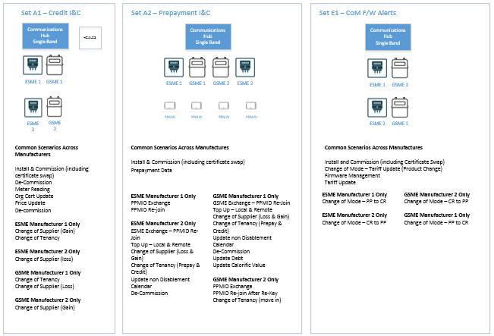
Figure 1: Single Band - Core Sets
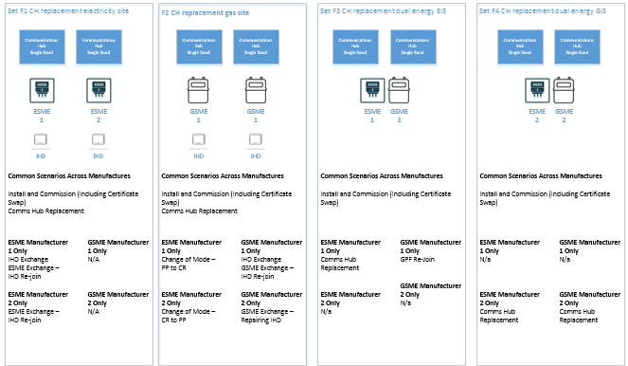
Figure 2: Single Band - Non Core Sets

Figure 3: Dual Band - Core Sets
Figure 4: Dual Band - Non Core Sets

- Plan on Page
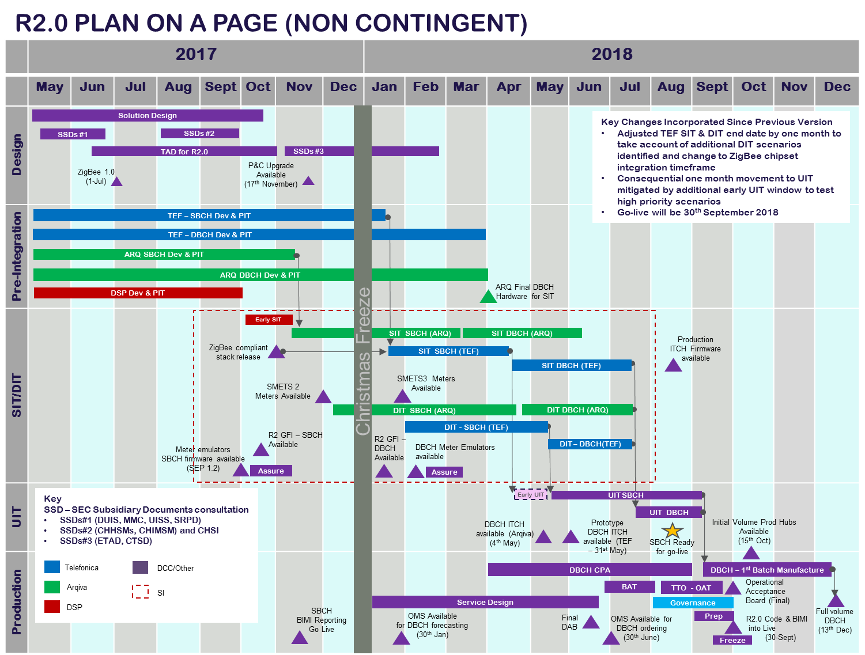

Device can be: Electricity Smart Meter, Gas Smart meters, In Home Display Unit, Prepayment Interface Device, Customer Access Device, Han Connected Auxiliary Load Control Switch or Hand-Held terminals. Should any be enrolled at the stage of selection then DCC should include them in the scope of DIT.
There are no specific test scenarios to test frequency agility and duty cycle monitoring, but the systems integrator will record events from testing to evaluate the performance of the Communications Hub in respect of these two bullets.
This document is a DCC Controlled artefact, but has been provided to SEC Panel Testing Advisory Group and the Secretary of State. Following the completion of Device Selection, DCC will consider making it available to SEC Parties
Final Scope of DIT regression testing to be confirmed
Final Scope of DIT regression testing to be confirmed
Two service user simulators may be required for change of supplier or other SRs that involve the interaction with two or more party roles.
For example: CH1 may complete testing by successfully passing SRs with ESME1 and ESME2 plus only GSME2 and IHD1 or any combination of the selected device. CH2 may then complete with ESME2 only GSME1 and GSME2 and IHD 2. CH3 may complete with another combination of selected devices. The DCC may employ a “Heatmap” to report this type of test completion. This is on the proviso that the issues encountered are not related to Communications hub but proved to be in the end device.

