MP116 ‘Service Request Forecasting’
This document is classified as White in accordance with the Panel Information Policy. Information can be shared with the public, and any members may publish the information, subject to copyright.

March 2021 Working Group – meeting summary
Attendees
Attendee | Organisation
Ali Beard | SECAS
Khaleda Hussain | SECAS
Holly Burton | SECAS
Huw Exley | SECAS
Brad Baker | SECAS
Joey Manners | SECAS
Anik Abdullah | SECAS
David Walsh | DCC
Remi Oluwabamise | DCC
Julie Geary | E.ON
Alex Hurcombe | EDF
Terry Jefferson | EUA
Laurie Walker | Gilmond Consulting
Ralph Baxter | Octopus Energy
Emslie Law | OVO-SSE
Elias Hanna | Smart ADSL
Matthew Alexander | SSEN
Daniel Davies | Utiligroup
Rachel Norberg | Utilita
Gemma Slaney | WPD
Overview
The Smart Energy Code Administrator and Secretariat (SECAS) provided an overview of the issue identified by MP116 ‘Service Request Forecasting’, the Proposed Solution put forward by the Data Communications Company (DCC) and also a summary of the updated draft legal text. The DCC also provided an update on their forecast modelling project.

  - Issue:
- Each quarter a DCC User must submit an eight-month Service Request forecast
- Each forecast takes approximately two days to complete per DCC User
- Experience has shown that the forecasts submitted are often inaccurate

  - Proposed Solution:
- Remove obligation on DCC Users to submit quarterly Service Request forecasts
- The DCC shall provide a report on the 15th Working Day of the months of January, April, July and October. This will set out a forecast of the number of Service Requests that the DCC expect will be sent in each of the nine months following the end of the reported month
- The DCC shall provide a report on the 10th Working Day following the end of the month that sets out the number of Service Requests sent during that month, a report setting out the current value for every Monthly Service Metric and a comparison of the current value against the relevant Monthly Service Threshold
- The DCC shall provide a report to the Smart Energy Code (SEC) Panel that sets out the aggregate number of Service Requests sent by all Users collectively during that month. Comparisons between actual numbers and the most recent forecast will be included
- The DCC shall provide commentary for any identified reasons why the expected level of accuracy has not been met
- DCC Users will be requested to feed into the DCC forecasts and make the DCC aware of any scenarios that could result in an increased number of Service Requests being sent

  - DCC forecast modelling project themes:
- DCC Service Request forecasts are shown to have typically aligned to actual volumes
- The Service Requests with the greatest variance between forecast and actual are associated with installations and firmware
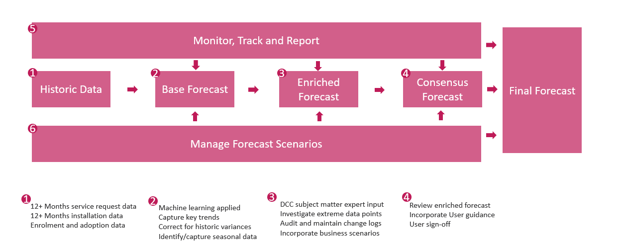
- Forecast process overview:

- Consensus forecast and sign-off process:
  - Review and influence industry traffic, behaviour and trends
  - Quarterly meeting of User representatives who can advise the DCC on User behaviour
  - Enriched forecast available to User representatives 5 Working Days before the review
  - Forecast variance presented and proposals discussed to correct areas of significant variance
  - Business scenarios reviewed and amended or additions proposed and agreed
  - Final forecast shared with SEC Panel / OPSG for review and sign off
  - If sign off is conditional then forecast is updated and provided for offline sign-off 5 days after the Operations Group meeting (OPSG)
  - Sign off required 10 days following OPSG
- Forecast variance reporting:
  - Published on DCC SharePoint available to all Users
  - Presented at OPSG in the months of March, June, September and December
  - Forecast Variance Report of top 25 Service Request Variants (SRVs)
  - Covers previous period of previous forecast
  - Provides commentary on variance and route to correct variance
Working Group discussions
SECAS presented the issue to the Working Group who acknowledged the issue and added no further comments.
SECAS provided a breakdown of the Proposed Solution. The Working Group are happy for the obligation to be removed on the DCC User, with the assurance that the DCC can facilitate the level of DCC User usage from the new forecasting process and the input required from DCC Users is clearly defined.
The Working Group was concerned with the role of the DCC User under the Proposed Solution, specifically that Users would be required to still submit information and forecasts around exceptional use (for instance if a new price cap was due to be implemented or if the User expected to perform a firmware upgrade). In the current solution, there is ambiguity around the details as to what is required of the DCC User once obligations are removed. The Working Group believed that the role of the DCC User in the Proposed Solution should be explicitly set out within a guidance document. It was suggested that it should be included within the DCC Anomaly Detection Threshold (ADT) and Forecasting Guidance Document.
The Working Group suggested that the User’s role should be included within the document before the modification progresses to the Refinement Consultation. This will allow for more informed consultation responses. It was also suggested to amend the legal text to include a reference to the guidance document. This will also be considered by the Proposer. The DCC advised that the added guidance would have to be run by the Design Release Forum.
As stated in a previous Working Group discussion, members want clarity regarding what will be expected of the SEC Party to allow them to allocate resource accordingly. If they are still required to validate the DCC forecasts and provide additional information as to any exceptional usage, they will still need to keep their forecasting resources in place and will not receive any benefits from the modification.
The DCC provided a detailed breakdown of their forecast modelling process. The Working Group queried whether the forecast process would account for industry-wide changes, such as a change stemming from the Balancing and Settlement Code (BSC). The DCC responded that they are aware of these changes and will be calling on their Regulation Team to feed into the ‘Enriched Forecast’ stage of the process. This was met with some scepticism due to the DCC previous not being aware of the impact of an industry-wide price cap.
The DCC sought to clarify the discrepancy between the number of Service Requests a DCC User has sent and what has been counted by the DCC. The DCC confirmed that this was caused by filtering attributes from the DCC perspective. The DCC confirmed that their numbers are significantly closer to those of DCC Users once filtering has been removed.
Critical Commands were discussed as the DCC apply these in two parts once received from the relevant User. The DCC confirmed that they only count this as one Service Request.
The DCC gave an overview of the ‘Consensus Forecast’ stage of the forecast process, which is where DCC User input will be required. The Working Group questioned the approach of gathering the DCC User input. The DCC suggested it would be through a focused group or via the SEC Operations Group (OPSG). The Working Group advised that each type of SEC Party would need to provide feedback on expected behaviour, which could result in a large group that may present significant logistical issues, with regards to availability and commercial considerations.
The Working Group highlighted a key point that although approximately 20 Service Request Variants (SRVs) cause 90% of traffic, this will not always be the case and so the DCC should not solely focus on these SRVs. Currently unused SRVs may well be used in high volumes in the future and so should not be discounted.
Furthermore, the Working Group commented that there will be situations where Service Requests will need to be resent. This will result in inaccurate forecasts. For example, firmware upgrades can be unsuccessful across a large volume of Devices, which will then result in a second attempt which cannot be forecast.
The DCC presented the business scenarios which they believe should be included in the forecasts and asked the Working Group which other scenarios, events or changes in behaviour need to be included. The Working Group suggested that changes to User’s business processes will need to be included as this could potentially impact the number of Service Requests being sent. The DCC ruled out the need to include DCC User testing.
A Working Group member commented that the capacity of the DCC System is significantly larger than what is currently forecasted, however this could be under threat if a large number of different Service Requests are sent at once.
The Working Group agreed that the modification needs further refinement and more detail added to the DCC User input before the modification can progress to the Refinement Consultation. SECAS will work with the Proposer and DCC to answer the key points raised by the Working Group before returning to a future meeting.

Next Steps
The following actions were recorded from the meeting:
- SECAS will work with the Proposer and DCC to investigate adding guidance on DCC User input
- SECAS will present MP116 to the Working Group once the solution is further refined
- The DCC are to provide a more detailed flow diagram of the Proposed Solution as part of the next Working Group meeting materials.

