This document is classified as **White** in accordance with the Panel Information Policy. Information can be shared with the public, and any members may publish the information, subject to copyright.



**Modification Report**

**Version 0.1**

**18 August 2020**

**DP139**

**‘MVP and IVP dates for CHTS’**

About this document

This document is a draft Modification Report. It currently sets out the background, issue, and progression timetable for this modification, along with any relevant discussions, views and conclusions. This document will be updated as this modification progresses.

Contents

1. Summary 3

2. Issue 4

Appendix 1: Progression timetable 5

Appendix 2: Glossary 6

Contact

If you have any questions on this modification, please contact:

**Emmanuel Ajayi**

020 8132 4134

[emmanuel.ajayi@gemserv.com](mailto:emmanuel.ajayi@gemserv.com)

# Summary

This proposal has been raised by Sasha Townsend from the Data Communications Company (DCC).

The Smart Energy Code (SEC) contains a number of Technical Specifications:

* Schedule 8 ‘Great Britain Companion Specifications’ (GBCS);
* Schedule 9 ‘Smart Metering Equipment Technical Specifications’ (SMETS);
* Schedule 10 ‘Communications Hub Technical Specifications’ (CHTS); and
* Schedule 11 ‘Technical Specification Applicability Tables’ (TSAT).

Schedule 11 ‘Technical Specifications Applicability Tables’ (TSAT) specifies the dates in which Devices built to these specifications can be installed (the Installation Validity Period (IVP)) and maintained (the Maintenance Validity Period (MVP)).

There are three issues that the Proposer is looking to address. The first issue relates to Communication Hub (CH) stock compliant to CHTS v1.0 and GBCS v1.0 and GBCS v1.1 being held in volume and unlikely to be installed before the IVP end date 31 January 2021. The second issue relates to the requirement to upgrade or replace installed CHTS v1.1/ GBCS v2.0 Communications Hubs to CHTS v1.1/ GBCS v2.1 Communications Hubs by 28 February 2021, the GBCS v2.0 Applicability Period end date. The third issue focuses on the need to upgrade/replace installed CHTS v1.1/ GBCS v2.1 Communications Hubs (to CHTS v1.3/ GBCS v3.2 Communications Hubs) by 31 May 2021, the CHTS v1.1 MVP end date.

The Proposer believes the wider impact is the risk that there will a period where Single Band and Dual Band Communications Hubs will be non-compliant if the current IVP end dates remain. The proposer also believes there is a high risk that Energy Suppliers will have stock that they can no longer install, therefore, will need to be scrapped.

# Issue

## What are the current arrangements?

The SEC sets out the Smart Metering Technical Specifications, including CHTS and GBCS. Schedule 11 ‘TSAT’ specifies the dates in which Devices built to these specifications can be installed the IVP and maintained the MVP. The TSAT also specifies the Applicability Period end date for the relevant version of GBCS. This means the date by which Parties should have taken all reasonable steps to ensure a Device is no longer operating on that version of GBCS.

Table 3 of TSAT, shown below, set outs the IVP, MVP and Applicability dates for CHTS and GBCS.

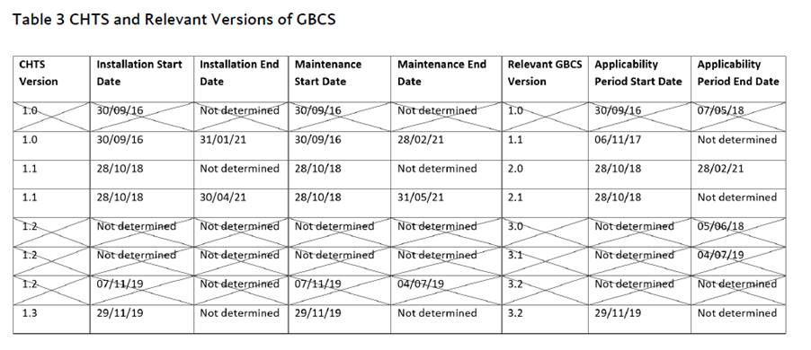

## What is the issue?

There are three issues:

### Issue 1: Uninstalled CHTS v1.0 Communications Hubs.

This issue relates to Communication Hub stock compliant to CHTS v1.0 and GBCS v1.0 and GBCS v1.1 being held in volume and unlikely to be installed before the IVP end date 31 January 2021.

The DCC Release 1 Communications Hubs across all regions were manufactured to CHTS v1.0 with firmware versions supporting both GBCS v1.0 and GBCS v1.1. These remain in warehouses pending installation. Until they have been successfully installed and commissioned that cannot be upgraded to a compliant CHTS v1.1 baseline. This means that the IVP end date of 31 January 2021 for CHTS v1.0/GBCS v1.0 will need extending.

### Issue 2: Delays in Communications Hub firmware deployment to upgrade from GBCS v2.0 to GBCS v2.1.

This issue relates to the need to upgrade or replace installed CHTS v1.1/ GBCS v2.0 Communications Hubs to CHTS v1.1/ GBCS v2.1 Communications Hubs by 28 February 2021, the GBCS v2.0 Applicability Period end date. The proposer believes it will not be possible to achieve this due to delays in CHTS v1.1/ GBCS v2.1 Communications Hub firmware deployment.

Communication Service Provider (CSP) North

GBCS v2.0 compliant firmware for the Single Band Communications Hubs (SBCH) in the North Region was made available on the Central Product List (CPL) in July 2020 with mass Over-the-Air (OTA) updates due to be deployed from late September 2020, anticipated to take several months to complete.

GBCS v2.1 compliant SBCH firmware in the North Region will not be available until March 2021. This date is after the 28 February 2021 Applicability Period end date for CHTS v1.1 and GBCS v2.0. From March 2021, mass OTA updates will be required to upgrade the production estate onto the GBCS v2.1 compliant firmware which is anticipated to take several months.

GBCS v2.0 compliant firmware for the Dual Band Communication Hubs (DBCH) in the North region is due on the CPL in August 2020, with the GBCS v2.1 compliant firmware not expected to be available until February 2021 at the earliest.

This means the current GBCS v2.0 Applicability Period end date of 28 February 2021 is not compatible for either Single Band or Dual Band in the North region and will need to be extended. It also means that the CHTS v1.1/GBCS v2.1 IVP end date will need to be extended.

CSP Central and South

DBCHs compliant with CHTS v1.1 and GBCS v2.1 in the Central & South Region will be made available in production from November 2020. Based on the forecasts provided by Energy Suppliers, it is estimated that installations of GBCS v2.1 compliant DBCHs are extremely unlikely to be complete by the current CHTS v1.1/GBCS v2.1 IVP end date of 30 April 2021 which means it needs to be extended.

### Issue 3: Upgrades to CHTS v1.1/GBCS v 2.1 Communications Hubs

This issue relates to the need to upgrade/ replace installed CHTS v1.1/ GBCS v2.1 Communications Hubs (to CHTS v1.3/ GBCS v3.2 Communications Hubs) by 31 May 2021, the CHTS v1.1 Maintenance Validity Period end date. The proposer believes it will not be possible to achieve this due to delays in CHTS v1.3/ GBCS v3.2 Communications Hub firmware deployment.

Both CSPs

Furthermore, due to re-plans of CHTS v1.3 and GBCS v3.2 compliant Communications Hubs firmware the MVP end date will need to be extended. This is because the full set of firmware releases across Single Band, Dual Band as well as all three Communications Hub providers will not all be available on the CPL and the existing estates having been upgraded before the CHTS v1.1/GBCS v2.1 MVP end date of 31 May 2021.

## What is the impact this is having?

The Proposer believes the current Applicability Period end date for GBCS v2.0 and the IVP/MVP end date for CHTS v1.1/GBCS v2.1 means there is a risk that there will a period where Single Band and Dual Band Communications Hubs will be non-compliant with a version of CHTS/GBCS with valid end dates.

Furthermore, if the current IVP end dates remain, there is a high risk that Energy Suppliers will have stock that they can no longer install, therefore, will need to be scrapped. The Proposer also believes there is a high risk that there will be a period where Suppliers can no longer install Communications Hubs due to CHTS v1.3 and GBCS v3.2 compliant Communications Hubs not being available.

# Appendix 1: Progression timetable

This Draft Proposal was raised on 18 August 2020 and will be presented to the Change Sub-Committee (CSC) for discussion on 25 August 2020.This Modification is targeted for the July 2021 Release.

| Timetable | |
| --- | --- |
| Event/Action | Date |
| Presented to CSC for final comment and recommendations | 28 Aug 2020 |
| Panel converts Draft Proposal to Modification Proposal | 11 Sep 2020 |
| Modification discussed with Working Group | 7 Oct 2020 |
| Refinement Consultation | 12 Oct – 30 Oct 2020 |
| Modification Report approved by Panel | 13 Nov 2020 |
| Modification Report Consultation | 16 Nov – 6 Dec 2020 |
| Change Board Vote | 18 Dec 2020 |

# Appendix 2: Glossary

This table lists all the acronyms used in this document and the full term they are an abbreviation for.

| Glossary | |
| --- | --- |
| Acronym | Full term |
| CH | Communications Hub |
| CHTS | Communications Hub Technical Specification |
| CPL | Commercial Products List |
| CSC | Change Sub-Committee |
| CSP | Central Service Provider |
| DCC | Data Communications Company |
| DBCH | Dual Band Communications Hubs |
| GBCS | Great Britain Companion Specification |
| IVP | Installation Validity Period |
| MVP | Maintenance Validity Period |
| OTA | Over the Air |
| SBCH | Single Band Communications Hub |
| SEC | Smart Energy Code |
| SMETS | Smart Metering Equipment Technical Specifications |
| TSAT | Technical Specifications Applicability Tables |