Process for Incorporating Issue Resolution Proposals and Non GBCS Non Mandated Alerts into the SEC
This document is classified as White in accordance with the Panel Information Policy. Information can be shared with the public, and any members may publish the information, subject to copyright.
SEC Consultation

Responding to this consultation
This is a Smart Energy Code (SEC) consultation relating to the Process for Incorporating Issue Resolution Proposals (IRPs) and Non GB Companion Specification (GBCS) Non Mandated (NGNM) Alerts into the SEC.
We invite you to respond to this consultation and welcome your responses to the questions set out at the end of this document. To help us better understand your views, please provide rationale to support your responses.
To help us process your response efficiently, please email your completed response form to sec.change@gemserv.com with the subject line ‘IRP Process Consultation response’.
If you have any questions or you wish to respond verbally, please contact Eessa Mansoor on 020 3890 8358 or email sec.change@gemserv.com.

Deadline for responses
This consultation will close at 17:00 on Friday 10 July 2020.
We may not be able to account for late responses.

Issue Resolution Proposals

Current arrangements

What are the Technical Specifications?
The SEC contains a number of technical specifications to ensure interoperability between Devices used in smart metering. These documents are:
- Schedule 8 ‘Great Britain Companion Specifications’ (GBCS)
- Schedule 9 ‘Smart Metering Equipment Technical Specifications’ (SMETS)
- Schedule 10 ‘Communications Hub Technical Specifications’ (CHTS)

What are Issue Resolution Proposals?
Issue Resolution Proposals (IRPs) identify issues within the SEC Technical Specification documents and put forward a solution to the identified problem. They can affect GBCS, SMETS or CHTS.
IRPs broadly fit into three categories: Data Communications Company (DCC) System impacting; non-DCC System impacting but impacts Devices; or non-DCC System impacting IRPs that affect the Technical Specification documents only. Any implementation of IRPs will change the Technical Specifications and therefore require an uplift to the version numbering of the corresponding documents.

How were these issues managed before?
In the early stages of the Smart Metering Implementation Program (SMIP), the Department of Business, Energy and Industrial Strategy (BEIS) took the lead in developing the Technical Specifications that sit under the SEC. This included receiving and responding to issues raised internally, by the DCC and by other interested industry Parties.
Since the inception of the SEC, several hundred such issues have been raised and discussed at the Technical Specification Issue Resolution Sub-Group (TSIRS). In some cases, these queries have been resolved by providing an explanation of the specifications, whilst others have resulted in proposed amendments to the specifications in the form of IRPs.
Following the discussions at the TSIRS, documentation is produced, and the IRPs are logged on the BEIS SharePoint site. Implementation was then facilitated through BEIS designations. Designations occurred at various times to implement vital changes into the SEC. As part of this process the IRPs were ‘swept up’ with larger changes such as Release 2.0 and the BEIS designation that will be implemented alongside the November 2020 SEC Release. In each case, BEIS consulted on the change and requested an assessment from the DCC which included the IRP changes.

Moving to the enduring arrangements
How will IRPs be managed in future?
As the transition phase comes to an end, BEIS is transferring the enduring processes to the Smart Energy Code Administrator and Secretariat (SECAS). IRPs will now be implemented into the SEC through the Modifications Process.
The Modifications Process requires that each change to the DCC Systems is assessed by the DCC to provide a Preliminary Assessment (PA) and an Impact Assessment (IA).

What is discussed at TSIRS?
IRPs will still (for the time being) be discussed at the TSIRS, until this moves from being governed by BEIS to being overseen by the Technical Architecture and Business Architecture Sub-Committee (TABASC). Discussions at this group establish what solution is required to issues (guidance or a technical fix). Whilst they are discussed with the DCC and DCC Service Providers, the detailed technical solution and the costs are not covered at this point. Whilst before this would have been addressed during the BEIS designation solution implementation, it will now be covered by the Modification Process through the DCC Assessments.

Proposed approach for managing IRPs
IRPs are expected to continue to be produced monthly at TSIRS. However, it would be inefficient to raise a modification every month and progress a small number of IRPs. For this reason, SECAS is proposing to raise a modification annually for each category to incorporate IRPs into the SEC.
The DCC will carry out four initial assessments per year, at quarterly intervals. These assessments will review all the IRPs raised in the preceding three months, to establish which category they fall into. This assessment will form the basis of the initial bundling of IRPs into modifications.
The DCC will categorise each IRP in one of three categories:
- Category 1 – Will impact the DCC Systems, requiring a Preliminary Assessment and an Impact Assessment during the Modification Process
- Category 2 – Will not impact DCC Systems, but will require regression testing by the DCC Service Providers
- Category 3 – Will not impact DCC Systems and will not require DCC testing.

The DCC initial assessment will not indicate if Category 3 IRPs will impact Devices or require Device Manufacturers to perform testing.

How has the timeline been determined?
To streamline changes and help manage version control of the SEC Technical Specifications Document, SECAS will endeavour to align all Modification Proposals that impact the Technical Specifications into one SEC Release per year. The November SEC Release (first Thursday of November each year) has been provisionally selected for this.
Due to the timelines required for the Modification Process, there is a cut-off point by which approved IRPs of a given type can be included. Once this point is reached, the scope is closed, and the approved IRPs are batched into a single modification. Subsequent IRPs will then begin to be targeted for the following year’s batch.

Category 1 IRPs
Category 1 IRPs will likely need a minimum 12-month lead time between approval and implementation; these IRPs will be bundled and progressed under one modification. This 12-month lead time is for the DCC System changes to be designed, developed and tested following approval.
Furthermore, as these modifications require DCC Assessments to be completed, enough time must be allowed for the relevant steps of the Modification Process to be completed.
To facilitate this, a Category 1 IRP batch modification will be raised in November every year. This is enough time to allow for the modification process and DCC Preliminary Assessment and Impact Assessment with a 12-month lead time between decision and implementation. The final cut off for including a Category 1 IRP in this batch will be December, to allow the DCC final initial assessment (marked as Q3 in Figure 1) to be completed and also incorporate any obvious Category 1 IRPs that are passed over from TSIRS during October and November. Any IRPs that are not obviously Category 1 will go into the next DCC initial assessment. Only once this scope is closed can the DCC then perform its Preliminary Assessment of the full batch; SECAS will request this in December, following the SEC Panel meeting. Final approval of the modification would be expected no later than the following October’s Change Board meeting, 12 months before go-live. This timeline is illustrated in Figure 1.

Category 2 IRPs
Category 2 IRPs will be bundled together and progressed under a separate modification with a nine-month lead time expected between approval and implementation. This lead time is to allow for testing of Category 2 IRPs and for Device manufacturers to implement the changes.
To allow for the Modification Process to be completed, the Category 2 IRP batches will need to be raised as a modification in October every year. The final cut off for including corresponding IRPs in this batch will be in July, to allow the final DCC initial assessment (marked as Q3 in Figure 1) to then be completed. Any IRPs that pass through TSIRS after July will not undergo DCC initial assessment until November (the Q3 DCC initial assessment will commence at the beginning of August and therefore IRPs agreed at the August TSIRS meeting will miss this assessment). As these modifications will not need to undergo the Refinement Process, the scope must be confirmed when the modification is raised. Change Board approval would then be expected in December, nine months ahead of go-live. This timeline is illustrated in Figure 1.

Category 3 IRPs
Category 3 IRPs will be progressed in a further separate modification. Progressing these IRPs under a separate Proposal will allow for a greater number of IRPs to be included in the proposal as they can be included closer to the Implementation date.
To allow for the Modification Process to be completed, the Category 3 IRP batches will need to be raised as a modification in May every year. The final cut off for including corresponding IRPs in this batch will be in January, to allow the final DCC initial assessment to then be completed. As these modifications will not need to undergo the Refinement Process, the scope must be confirmed when the modification is raised. The modification would proceed straight to the Report Phase and Change Board approval would then be expected in July, three months ahead of go-live. This timeline is illustrated in Figure 1.

The timelines outlined in Figure 1 are designed to achieve a decision in time for the changes to be implemented in the updates to the Technical Specifications (currently targeted for the November SEC Release each year). However, if this were to change then these timelines may be amended as appropriate.

What if an IRP needs to be implemented urgently?
Any IRPs identified by the TSIRS or the TABASC as requiring implementation more quickly than these standard timelines would allow will be included in a separate Proposal and progressed as a standalone modification.

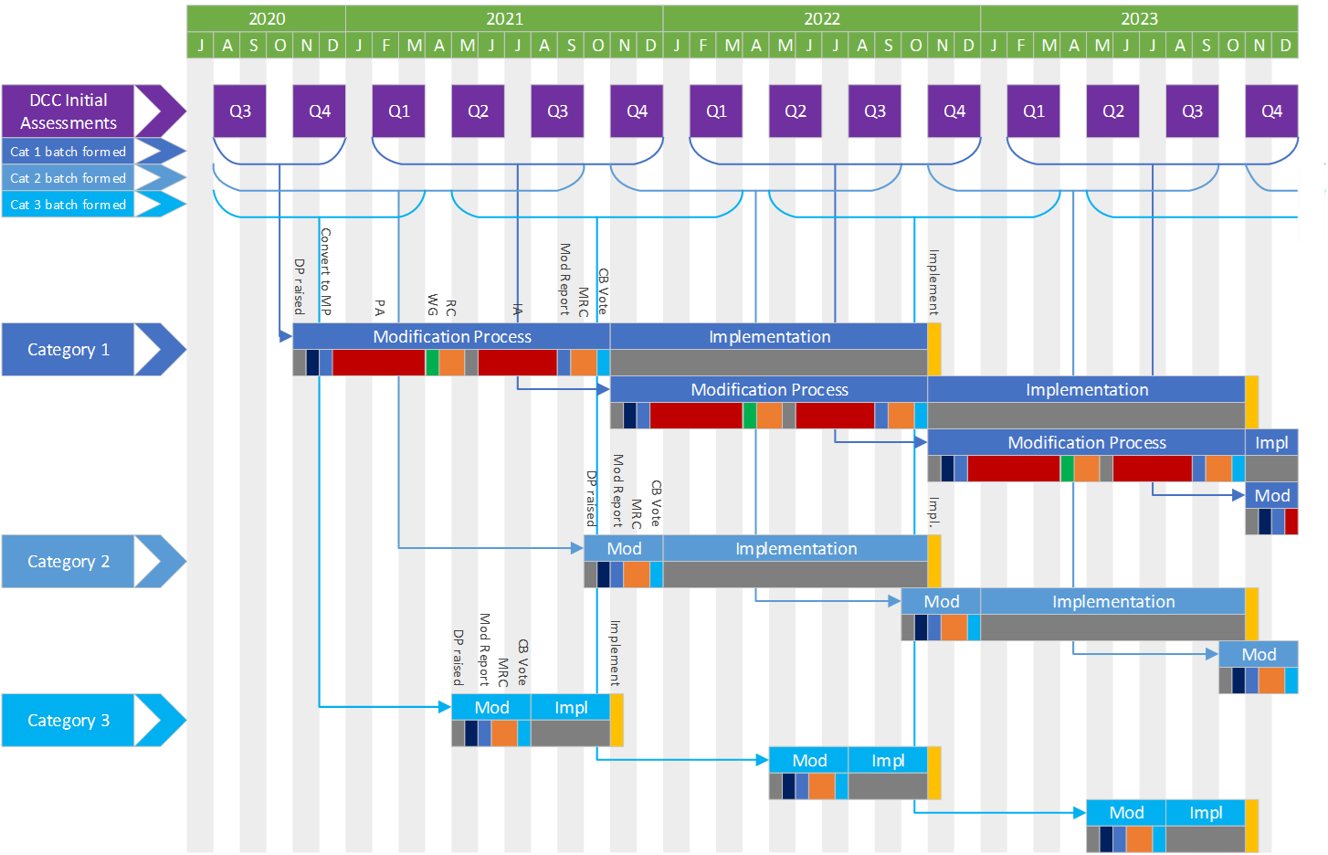
Figure 1 IRP batching and progression timetable

Non-GBCS Non Mandated Alerts

What are NGNM Alerts?
Device Alerts are unsolicited messages sent by Devices to DCC Users e.g. the Supplier. The GBCS defines the structure of the Alerts and contains a listing of Alerts, distinguishing between mandated and non-mandated Alerts.
GBCS Parse software allows any new non-mandated Alerts of the right format (as specified by the GBCS) sent by Devices to be passed to the DCC User. These new non-mandated Alerts are captured temporarily in the ‘Non-GBCS-Non-Mandated-Alerts-Register’ until they are adopted by the SEC:
Non GBCS Non Mandated Alerts Register

How were these issues managed before?
Suppliers and manufacturers have a general (but non regulatory) responsibility to ensure all Alerts supported by their Devices beyond those specified in the SEC are captured in the ‘Non GBCS Non Mandated Alerts Register’ until they are adopted by the SEC.
The form and process to raise a new NGNM Alert Code can be accessed using the following Excel Workbook:
Non GBCS Non Mandated Alert Form

How will they be managed in future?
To migrate these Alerts into the SEC, making them understandable (and configurable, if Parties prefer) by Users’ systems, there will be an impact to the DCC Systems and to the GBCS. Therefore, a modification that incorporates a number of these Alerts into the SEC will be required. This would need to undergo DCC Assessment and will need an anticipated minimum three-month lead-time to implement following approval.
SECAS proposes these modifications follow an identical timeline to that of Category 1 IRPs to ensure a decision is received before the six-month cut-off for System Impacting changes to be included in a SEC Release. To streamline and increase efficiency, NGNM Alerts that are to be migrated into the SEC will be included in the Category 1 IRPs modification, with the option to separate them out into a separate modification if they present a delay to the IRPs or vice versa.

Respondent details
Respondent details
Name | Click and insert your name
Organisation | Click and insert the name of the organisation you are responding for
Phone number | Click and insert a phone number we can call you on with any queries

Confidential information
Does your response contain any confidential information?
Response | Click and select your response
If ‘yes’, please clearly mark all confidential information (e.g. in red font).
Any confidential responses may be shared with the SEC Panel, SEC Change Board and the Authority under a Red classification in accordance with the SEC Panel Information Policy.

Consultation questions
Question 1
Do you agree with the outlined approach for implementing IRPs into the SEC?
Please provide your rationale.
Response | Click and select your response
Rationale | Click and insert the rationale for your response

Question 2
Are the stated anticipated lead times between Modification Proposal approval and implementation sufficient for your organisation to implement changes?
Please provide your rationale. Please note that these lead times are used as a default. It is understood that it may be dependent on what IRPs are being implemented to fully understand the lead time required.
Response | Click and select your response
Rationale | Click and insert the rationale for your response

Question 3
Do you agree with the outlined approach for implementing NGNM Alerts into the SEC?
Please provide your rationale.
Response | Click and select your response
Rationale | Click and insert the rationale for your response

Question 4
Do you agree with a targeted one uplift of the Technical Specification per year?
Please provide your rationale. Please note that while one Technical Specification uplift will be targeted each year, this is not a steadfast rule and, if the need arises, further uplifts will be possible.
Response | Click and select your response
Rationale | Click and insert the rationale for your response

Question 5
Please provide any further comments you may have.
Comments | Click and insert any further comments
Smart Energy Code Administrator and Secretariat (SECAS)

8 Fenchurch Place, London, EC3M 4AJ
020 7090 7755
secas@gemserv.com

