**Department for Business,**

**Energy & Industrial Strategy**

1 Victoria Street,

London SW1H 0ET

[www.gov.uk/beis](C:\\Users\\dstone\\Downloads\\www.gov.uk\\beis)

The Authority (Ofgem), the SEC Panel, SEC Parties, and other interested parties

2 August 2019

Dear Colleague,

**Consultation on Smart Metering System Proportional Load Control Functionality**

Smart meters provide a key platform for a smart and flexible energy system,[1] which has potential cumulative benefits of up to £40 billion by 2050. Shifting demand away from peaks helps to minimise the amount of new electricity generation and network capacity needed and can also maximise use of low carbon generation. Smart meters enable energy suppliers to pass on savings via smart energy tariffs that reward consumers who shift demand to times when it is cheaper to supply.

The smart metering system has also been designed to provide a secure and interoperable means for consumers to manage demand in an automated manner, further helping to deliver a smart and flexible energy system and associated savings for consumers. This enables, for example, the automated charging of an electric vehicle for when it is needed at the cheapest times. However, more granular control will be needed than is currently available for certain loads, as recognised in the separate government consultation on the overall approach to regulating electric vehicle smart charge points.[2] The smart metering system is government’s current lead enduring option for electric vehicle smart charging in the call for evidence that is part of that consultation. Government considers it to be strategically important that the smart metering system is developed and maintained in a cost-effective manner such that it can effectively perform such a role.

This letter and its annexes comprise a consultation on government’s proposal to add proportional load control functionality to the Smart Metering System. This relatively small and incremental change will build on existing Auxiliary Load Control Switch (ALCS) and Home Area Network (HAN) Connected Auxiliary Load Control Switch (HCALCS) functionality to enable more precision and flexibility in the control of load than is currently possible. This is intended for use in effective management of significant loads such as electric heating systems and the smart charging of batteries and electric vehicles. The consultation includes proposed drafting changes to the SMETS2 technical specification to deliver this outcome.

This consultation runs until 20 September 2019. Details of how to respond are provided in Annex A.

Yours faithfully,



**Duncan Stone**

Deputy Director and Head of Delivery,

Smart Metering Implementation Programme

**Annexes:**

Annex A: Consultation Document

Annex B: Use Cases

Annex C: APC and SAPC Diagrams

Annex D: Proposed SMETS2 Drafting (embedded document)

**Annex A – Consultation Document**

1. **Summary**

This consultation concerns a proposal to add new proportional load control functionality to the Smart Metering Equipment Technical Specifications (SMETS2). This will build on existing Auxiliary Load Control Switch (ALCS) and Home Area Network (HAN) Connected Auxiliary Load Control Switch (HCALCS) functionality to allow more precision and flexibility in control of load than is currently possible. This is intended for use in effective management of significant loads such as electric heating systems, batteries and electric vehicles. This consultation includes proposed drafting changes to SMETS2.

1. **Context**

The development of a world-leading smart energy system delivering secure, cheap and clean energy is an important part of the Government’s Industrial Strategy[3]. As our Clean Growth Strategy highlights, smart technologies and services will play a vital role in decarbonisation[4]. Smart meters are a vital upgrade to our national energy infrastructure, not only putting consumers in control of their energy use, but also providing the building blocks of a more flexible and resilient energy system fit for the 21st century. The smart systems and flexibility plan estimated that this could bring consumers, the energy industry and wider economy between £17 billion and £40 billion of benefits over the next few decades[5].

Smart meters provide a platform for the delivery of a smarter and more flexible energy system, and a competitive energy market. Smart Metering enables demand side response in two ways. Firstly, Smart Metering allows consumers to benefit from incentives to shift demand to times when it is cheaper to supply through enabling smart energy tariffs that are enabled by half-hourly metering. Secondly, the smart metering system has also been designed to provide a secure and interoperable means of allowing consumers to manage demand in an automated manner and to provide coverage to a minimum of 99.25% of premises in GB. This enables, for example, the automated charging of an electric vehicle (EV) for when it is needed at the cheapest times.

Government is currently consulting on its approach to regulating EV charge points, and as part of this, is conducting a call for evidence on long-term options for electric vehicle smart charging more broadly[6]. Enduring options are being considered against four objectives: grid protection (including security), consumer protection (including interoperability), consumer uptake and innovation. The call for evidence states that Government’s current lead long-term option is for EV smart charging to be conducted via the smart metering system on the basis of its fit against these objectives, in particular those on grid protection and consumer protection, and that it already exists across Great Britain.

The remote control of domestic loads, with consumer consent, through the smart metering system is currently provided for through the auxiliary load control functionality present in SMETS2 smart meters. However, industry engagement has indicated that this functionality does not provide sufficient precision or flexibility to allow effective management of significant loads such as batteries and electric vehicles, and this is considered a strategic requirement for the Government’s EV smart charging policy.

Engagement with industry parties prior to publishing this consultation has taken place via Smart Energy Code (SEC) governance mechanisms in the form of discussions at the Smart Metering Implementation Programme Technical Business Design Group (TBDG) on the context and need for this functionality, and the Technical Specifications Issues Resolution Subgroup (TSIRS) where initial technical discussions on the SMETS drafting took place. In addition to this an open industry workshop (beyond SEC parties, attended by consumer groups, manufacturers and DNOs) discussing the context for and utility of this functionality was held earlier this year, supported by informal bilateral industry engagements. It is also of relevance that BEIS is currently supporting two projects which will demonstrate the existing load control functionality of the smart metering system in the context of EV smart charging. These projects commenced in April this year and will conclude in March 2021.

1. **Proposed SMETS2 Changes**

We are proposing to add new proportional load control functionality to the second-generation Smart Metering Equipment Technical Specifications (SMETS2), building on existing Auxiliary Load Control Switch (ALCS) and Home Area Network (HAN) Connected Auxiliary Load Control Switch (HCALCS) functionality, but with the potential to set an output at any level between 0% and 100%. This functionality has potential for application across a range of equipment including EVs, heat pumps and batteries.

Our draft proposed SMETS2 changes are set out at **Annex D** to this consultation and also available on the [SECAS website](https://smartenergycodecompany.co.uk/latest-news/beis-consultation-new-replacement-obligation-nro-activation-date/). GBCS and other specification changes will be drafted subject to the outcome of this consultation. The following sections of SMETS2 have been amended/created as a result of these changes:

* 3 Introduction
* 5 Electricity Smart Metering Equipment Technical Specifications
  + Part A – Single Element Electricity Metering Equipment
  + Part E – Boost Function
  + Part F – Auxiliary Proportional Controller
* 8 HAN Connected Auxiliary Load Control Switch Technical Specifications
  + Inclusion of IRP 591 which clarifies HCALCS behaviour for future dated commands; use of acronyms to improve readability
* 9 Standalone Auxiliary Proportional Controller Technical Specifications
  + Part A – Standalone Auxiliary Proportional Controller
  + Part B – Auxiliary Load Control Switch
  + Part C – Boost Function
* Glossary

We are proposing to introduce new Auxiliary Proportional Controller (APC) functionality into SMETS that can be implemented in two ways (illustrated at **Annex C**):

* New APC functionality that can be added to Electricity Smart Metering Equipment (ESME) (in the same way ALCS and Boost can); and
* New HAN-connected Standalone Auxiliary Proportional Controller (SAPC) functionality that will connect to the HAN via the Communications Hub.

Using APC functionality, a proportional output value can be set according to a calendar (schedule). This value can also be dynamically controlled. The APC and SAPC will be an optional part of SMETS2, in the same way that ALCS and HCALCS devices were also introduced as optional (i.e. were not a compulsory part of the specification which must be offered to all consumers). It will therefore be up to energy suppliers to determine if they wish to deploy or offer new proportional load control functionality to their customers. Use of any load control functionality will be subject to consumer consent

**Value of Greater Precision**

Legacy loads such as storage heating and water heating are suited to simple on/off which is possible with existing ALCS control. Newer loads such as batteries and heat pumps offer greater flexibility in terms of charging and discharging rates. This flexibility, which has benefits, both for consumers and in overall electricity system management, can only be fully exploited with multi-level control. Examples of where this greater flexibility could be useful are given in **Annex B**.

Industry stakeholders, including several energy suppliers who are active in the utilisation of load control, have already developed and installed in homes, their own systems which deliver smart charging. These currently operate outside of the smart metering system. These systems, many of which are proprietary, have functionality equivalent to the proportional load control proposed here. Government understands that current systems operating outside the smart metering system may not necessarily have robust measures equivalent to smart metering that address cyber security risks associated with load control at scale and are unlikely to maintain smart functionality across operators – in other words, they are not interoperable. Government sees both cyber security and interoperability as critical elements to any system which delivers load control functionality at scale.

Some industry stakeholders have raised the binary nature of ALCS and HCALCS as problematic in effective smart charging. BEIS has worked with industry to understand these concerns better and developed example situations of where it can see proportional load control functionality would be beneficial (see Annex B – Use Cases).

Government sees the addition of proportional control as a relatively small addition to the existing smart metering load control functionality, which requires only a Data Communications Company (DCC) Data Services Provider (DSP) system change (as opposed to one requiring changes to communication hubs which is much more onerous and expensive), with limited system costs in the broader context.

The change proposed here is therefore an incremental change which, based on industry engagement so far, Government believes will enable the smart metering system to offer an effective method for smart control across a range of loads. Government is also keen to ensure there is an effective option for industry which also delivers on interoperability and cyber security, where presently there is no other system in place which can achieve this. Associated with this, Government considers that it is strategically important to maintain and develop the smart metering system, which is currently the lead enduring option for EV smart charging, so that it is fully ready for use ahead of Critical National Infrastructure-level loads of EV smart charging.

* 1. **Do you agree that this proposal adds value over existing smart metering load control functionality? Please provide supporting rationale including, if you disagree, explanation of how the use cases in the annex could be met with existing functionality or are not relevant.**

**Control of Power and Interpretation of Signals**

The proposed SMETS2 changes are intended to allow for a broad potential of devices. Drafting is intended to allow for devices which control or limit the flow of power to a load or load interfacing device (e.g. an electric vehicle smart charge point). The drafting is also intended to allow for APC signals to be interpreted by the load interfacing device to set its output at different levels (e.g. allowing an electric vehicle smart charge point to react to a signal to reduce or increase power to the vehicle). This flexibility is intended to maintain relevance of the specification across as broad a range of applications as possible.

* 1. **Do you agree with our intention to enable a broad range of devices e.g. both ones that can control flow of power and ones that send a signal to set output power at different levels? If you disagree please explain why, and what your preferred way of delivering proportional load control is.**

**Specified Units of the APC Functionality**

It is proposed that the new APC functionality is specified in a way which provides for output as a percentage, rather than, for example, a kW figure. This is on the basis that we consider the percentage approach offers greater implementation options and greatest scope for innovation as for example it does not place constraint on the size of load.

The percentage setting, coupled with configurable Description Labels that allow the type of load connected to be described (e.g. in terms of type and size), should provide the operator with sufficient information to ascertain what the kW value could be, should it be required. This follows the same logic as the ALCS and HCALCS specification where no unit or rating was specified associated with the two levels of control possible.

* 1. **Do you agree that the maximum output should be configured as a percentage rather than another unit such as a kW value? Please provide supporting rationale for any alternative suggestions.**

**Frequency Response**

We have considered support for frequency response. In Government’s view, the functionality required to respond to changes in frequency can be built into the load (or load controlling device) outside of the SMETS specification. This frequency response mode could be set on to on or off modes using existing ALCS or HCALCS functionality. The smart metering system also has existing ability to store and retrieve consumption data which can facilitate monitoring and verification of provision of services. Therefore, we do not consider additional functionality is required to deliver frequency response and control this via the smart metering system.

* 1. **Do you agree that no further functionality is required to allow smart metering to control and support provision of frequency response services? If not, please suggest what additional functionality you think would be required and provide supporting rationale for its inclusion in your response.**

**Other Party Load Control**

Currently only energy suppliers can control load through the DCC system, and there are no changes within the scope of this consultation that would alter this. We are, however, proposing some minor future proofing of the devices (given likely asset lives) in the specification[7] which would allow the potential for proportional load control devices to act on a message from a user other than a supplier to curtail load. In the future, it could lead to the provision of demand side response services, offering consumers incentives for the provision of demand management services by a third party without that third party having to be or act through an energy supplier, as is currently the case.

However, this functionality will remain unusable by a DCC user unless Government or industry and Ofgem make or agree to further changes, which are outside the scope of this consultation. Specifically, the Smart Energy Code (SEC) in particular the User Interface Services Schedule (UISS) and DCC User Interface Specification (DUIS) Subsidiary Documents - and DCC system would need to be changed in order for another user to be able to send a load constraining message, and nothing in this consultation will change this. However, given the comparatively insignificant costs of adding this functionality into devices and of the associated DCC system changes, Government considers its inclusion prudent as part of light-touch future proofing given the expected lifespan of the devices, in case this functionality is required in years ahead.

* 1. **Do you agree the inclusion of the override functionality is a prudent future proofing measure? Please set out your rationale.**

1. **Detail on Changes to the Technical Specifications**

**Flexibility in APC Integration**

We have drafted the proposed changes to SMETS2 to maximise implementation and innovation potential for APC integration with a device which interfaces directly with the load or load interfacing device. The following options are possible:

* Fully integrated: load/load interfacing device and APC are fully physically integrated within the same case i.e. shared components.
* Partially integrated: load/load interfacing device and APC are operationally independent but in the same case.
* Separate: load/load interfacing device and APC are physically separate in different cases but connected via wired connections for data and power.

These integration options apply regardless of whether the APC is implemented as part of an ESME or as an SAPC.

**Meter Integrated and HAN Connected Forms of APC**

Both an ESME with APC and SAPC provide different ways of delivering the same functionality but both utilise the same straight forward DCC system changes. We believe providing two ways to deliver the outcome provides greater flexibility to industry with no additional system cost. The proposed SMETS drafting is available at **Annex D** and on the SECAS website alongside this consultation.

* 1. **Are there other SMETS changes that could further maximise implementation potential of APC functionality i.e. provide greater flexibility to industry in manufacturing, installing and operating devices?**
  2. **Do you agree that having two forms of APC (meter integrated, and HAN connected) allows valuable flexibility and is worthwhile given no additional system cost?**

**SMETS2 Version Control**

We believe it would be easier to introduce the new version of SMETS2 alongside existing versions, with no changes to installation and maintenance validity dates of existing versions as a result of the release of this new version of SMETS2. Additionally, we do not believe there is any requirement for these changes to be retrospective to installed equipment. The proposed SMETS2 changes include updating the commands to control ALCS, HCALCS and APC functionality, in order to allow a single new command for all three. This is with a view to reducing meter complexity and cost for those incorporating this functionality. However, recognising that introducing the new command as arequirement would reduce the optional nature of the APC functionality for both meter manufacturers and energy suppliers, we propose concurrent running of SMETS2 versions. We see limited downsides to this approach given the established precedent concurrent validity of multiple versions of SMETS2. We also see no reason why GBCS cannot be drafted in a way which allows the addition - post meter installation - of an SAPC to any SMETS2 installation – i.e. those meter installations made under older versions of SMETS.

* 1. **Do you agree with the proposed approach to maintain the new SMETS2 alongside the existing SMETS2 versions?**

**APC on Change of Supplier**

Industry stakeholders have raised concerns that whilst the proposed new functionality is optional, any energy supplier would need to support the relevant DCC Service Requests if a gained consumer had a device with APC functionality.

As DCC users have the option to not upgrade to the version of DUIS that supports APCs, there is the possibility that where a consumer changes supplier from one that does support APCs to one that doesn’t, a consumer continues to have their load controlled by a calendar set by the old Supplier.

We have considered three options for APC management on churn, in particular how an existing schedule in the calendar within the APC should be dealt with:

1. Not implementing any calendar clean-up functionality in the specifications. This would allow energy suppliers to determine among themselves how to address APC on Change of Supplier. There are two possible courses of action for energy suppliers in this scenario:
   1. Either leave any existing calendar entries as is on churn – meaning the charging pattern would be maintained but the new supplier would not have the ability to change this or dynamically manage the load, until they upgrade DUIS version.
   2. Or the losing energy supplier could cancel any existing calendar entries before the change of supplier takes place (e.g. such that the output is set to a constant maximum value). We note there is a precedent for obliging suppliers to do this in the case of a losing supplier having to switch a smart meter into credit mode prior to the change of supply event[8]. In this case an APC would default to maximum output. This would mean for example that a smart charge point would retain its basic function but no longer be smart.
2. Not implementing any calendar clean-up functionality in the specifications and rely on the gaining supplier to support the new DCC Service Requests. This would be consistent with smart metering being mandated as the enduring solution for electric vehicle smart charging, as the current lead enduring option proposed in Government’s recently published consultation on EV smart charging[9]. This could be implemented by requiring users to upgrade to a newer DIUS version via SEC Code change.
3. Implement calendar clean-up functionality in the specifications to automate cancelling any existing calendar entries on change of supply. The downsides of this approach are increased device complexity as it would have to carry out additional processing; and increased testing complexity and requirements.

Our view is that Option 1 appears most effective way to address the issue of churn to non-supporting suppliers in the short term, while Option 2 provides a potential long-term solution, pending the Government’s decision on an enduring EV smart charging solution. Option 3 has been ruled out based on the downsides indicated.

* 1. **Do you agree that no further changes to the specifications should be implemented to deal with change of supply events, meaning that suppliers can decide how to handle APC functionality on churn? Please provide your rationale.**

**Policy Intent and Scope of Changes**

We believe the changes deliver the policy intent of enabling proportional load control and that these represent the best balance of adding new functionality versus costs at this time.

* 1. **Do you agree that proposed drafting delivers the intended outcome? Do you have suggestions on how SMETS2 changes could be drafted to more effectively deliver this?**
  2. **Are there other requirements or functionality related to load control that should be added at this stage? Please provide supporting rationale for any additional suggestions.**

1. **Security Aspects**

BEIS will engage with the SEC Security Sub Committee to review whether a change to the existing Security Characteristics for this new functionality will be required once the GBCS enhancements are developed as a result of the functionality agreed through this consultation. This will include support from the National Cyber Security Centre (NCSC) and industry as required.

1. **Anticipated Costs**

The DCC has provided a preliminary Impact Assessment including an estimate of DSP costs through to Product Integration Test (PIT) complete, based on the implementation of five additional Service Requests, which ranges from £750k to £1.5m.

The DCC has also stated that not including the future proofing functionality to allow potential for other users to control load would reduce the upper cost margin from £1.5m to £1m, meaning that the estimated DSP costs would range from £750k to £1m.

However, only a full DCC Impact Assessment would determine the exact costs associated with the proposed changes. The final cost to implement into the “Live” system would be ascertained as part of the release management process and would be influenced by the type and level of concurrent change in the release in question.

1. **Implementation Timing**

DCC has indicated that it could implement the changes proposed here in mid-2020, provided Communications Hub changes are not necessary, which is assumed to be the case as set out above. The June 2020 SEC Release is therefore an option, or the November 2020 SEC Release depending on the timing of implementation of other SEC modifications during that period.

1. **Responding to this Consultation**

Responses to this consultation should be submitted no later than 20 September 2019.

Comments should be submitted to [smartmetering@beis.gov.uk](mailto:smartmetering@beis.gov.uk), or addressed to:

APC Consultation

Smart Metering Implementation Programme

Department for Business, Energy & Industrial Strategy,

2nd floor, Spur,

1 Victoria Street,

London SW1H 0ET

**Confidentiality and data protection**

Information provided in response to this consultation, including personal data, may be subject to publication or release to other parties, or to disclosure in accordance with the access to information regimes (primarily the Freedom of Information Act 2000, the Data Protection Act 2018 and the Environmental Information Regulations 2004).

Individual responses to this consultation may be published and you should therefore let us know if you are not content for your response or any part of it to be published. If you indicate that you do not want your response published, we will not publish it automatically but it could still be subject to information requests as detailed above. If you do not want your individual response to be published, or to otherwise be treated as confidential, please say so clearly in writing when you send your response to the consultation. For the purposes of considering access to information requests, it would also be helpful if you could explain to us why you regard the information you have provided as confidential. If we receive a request for disclosure of the information we will take full account of your explanation, but we cannot give an assurance that confidentiality can be maintained in all circumstances. An automatic confidentiality disclaimer generated by your IT system will not, of itself, be regarded by us as a confidentiality request.

**Annex B – Use Cases**

**Use Case 1: Some battery related devices need to be constantly powered to support a range of functions**

Whilst the desired power output to the battery might be zero power, the smart device itself (e.g. a charge point) will still need power to operate. Hence the need for a “standby” or “trickle” mode, as well as potentially two or more levels of power output to the load. In this case more than 2 power modes are required: ‘Standby' to delay consumption during most expensive periods - giving no output power; ‘Full power’ to maximise consumption during cheap periods; and various power settings to balance reduced consumption with cost-effective tariffs.

**Use Case 2: Battery-based devices should not be stopped mid-charge as it can reduce battery life and cause problems with control hardware**

Many batteries have a minimum charge rate once charging has started – falling below this minimum can affect battery operation and life. At the same time, to get the most value from smart charging, ideally one would charge at full power during the cheapest periods, and at low or no power during the more expensive periods. In this use case, 3 charging modes are required: ‘Standby' to delay charging during most expensive period - giving no output power; ‘Full power’ to maximise charging in cheap periods; and ‘Low power’ to minimise charging once it has started should prices rise again.

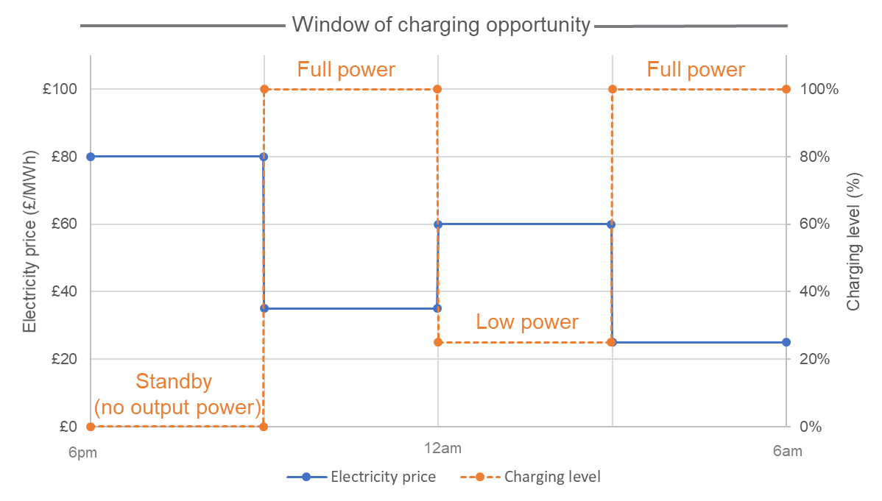

Figure 1. Use Cases 1 & 2

**Use Case 3: Reduction in charging level at congested times**

Allowing consumers to engage in provision of network management services may require a reduction of charging at periods of high demand. In this case it is likely to be preferable to consumer to reduce higher numbers of loads by a small amount rather than switch smaller numbers of loads “off”, particularly given battery impacts of doing so once charging has commenced as mentioned above. The small reduction is considered to be required in addition to the above-mentioned modes of “standby” and “low charge”.

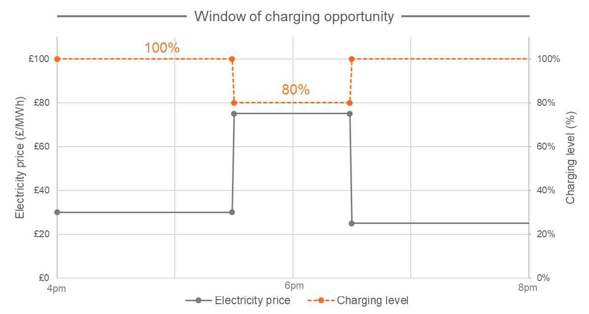

Figure 2. Use Case 3

**Annex C – APC and SAPC Diagrams**

Figure 3. We are proposing to introduce into SMETS two ways of implementing the Auxiliary Proportional Controller (APC) functionality in terms of meter integration and Home Area Network (HAN) connection

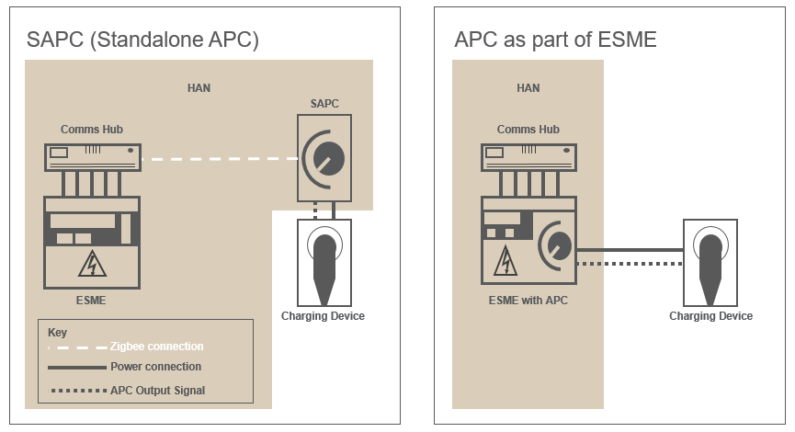

**Annex D – Proposed SMETS2 Drafting**



1. <https://www.gov.uk/government/publications/upgrading-our-energy-system-smart-systems-and-flexibility-plan>
2. <https://www.gov.uk/government/consultations/electric-vehicle-smart-charging>
3. <https://www.gov.uk/government/publications/industrial-strategy-building-a-britain-fit-for-the-future>
4. <https://www.gov.uk/government/publications/clean-growth-strategy>
5. <https://www.gov.uk/government/publications/upgrading-our-energy-system-smart-systems-and-flexibility-plan>
6. <https://www.gov.uk/government/consultations/electric-vehicle-smart-charging>
7. Ability for another party to override the calendar, supplier and boost control settings, whereby the override setting (if at a lower % of maximum than the current setting) will apply.
8. <https://www.spaa.co.uk/SitePages/CPDetails.aspx?UID=915&Source=https://www.spaa.co.uk/SitePages/CPArchive.aspx>
9. <https://www.gov.uk/government/consultations/electric-vehicle-smart-charging>