Smart Metering Implementation Programme

Technical Specification Issue Resolution Proposal

This note provides SMIP’s interim position on an issue identified with the current version of the Technical Specifications or their associated content. Please note this position should be considered as Draft until ratified through TBDG.

Date | 2 February 2024
Issue Resolution Proposal | IRP665
Issues Log ID | TS1622
Issue Title | Certification Path Validation clarification
Source | SMIP
Date Raised | 13 November 2023
Status | Draft v0_1
Documentation Reference | GBCS v4.3
Description:
Following explanation provided at TS1619 concerning Certification Path Validation in relation to applyTimeBasedCPVChecks it is noted that GBCS might benefit from some clarification.
The aim of the changes is to emphasise that Certification Path Validation only applies to the replacement Certificates and does not apply under any circumstance to existing Certificates held as credentials in Trust Anchor cells.

Proposed Position:
During testing, there was some uncertainty as to the circumstances under which Certification Path Validation (CPV) occurs.
The drafting changes proposed are to clear up any ambiguity there may be regarding the circumstances under which CPV occurs. CPV occurs only when an Update Security Credentials Command is received and applies only to the replacement Certificates contained within the Command.
The drafting changes also fix some minor discrepancies in the existing text.

Interoperability and /or Compatibility
There is no effect on existing device interoperability and DCC systems are not affected by this IRP665.

Required Changes to Documentation:
- At GBCS Section 4.3.2.8.2, add the clarification text as shown in the mark-up below:
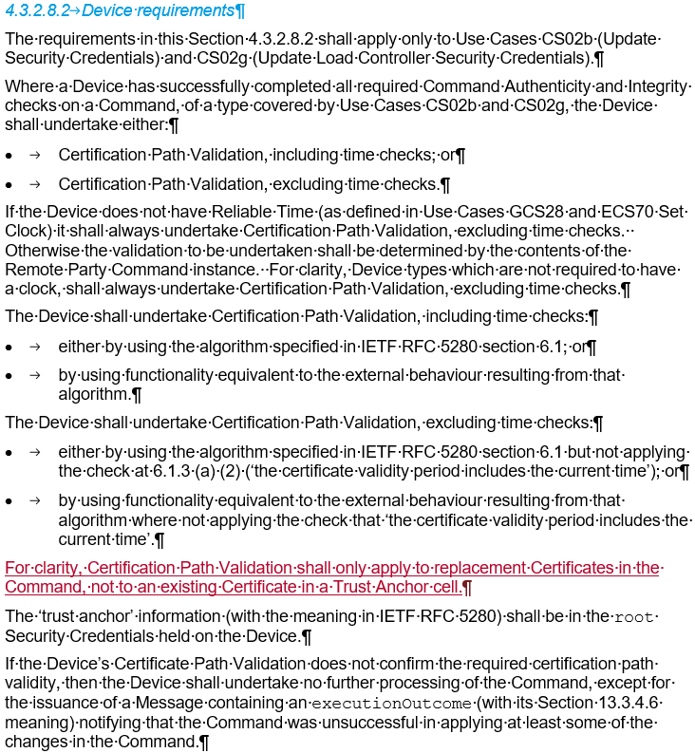
<run on as is…>

- At GBCS Table 13.3.4.1 amend the text in the ‘applyTimeBasedCPVChecks’, ‘replacements’, ‘trustAnchorCellUsage’ and ‘certificationPathCertificates’ rows, as shown in the marked-up. sections below:
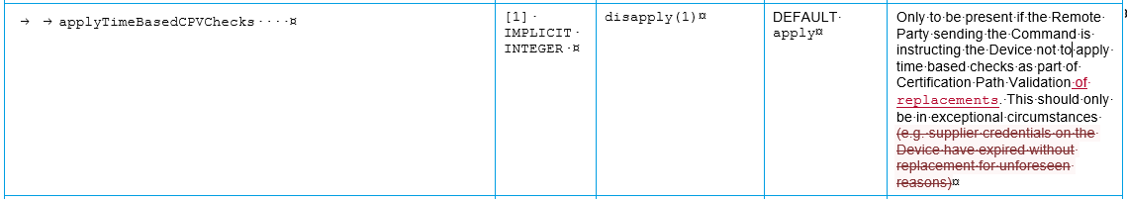
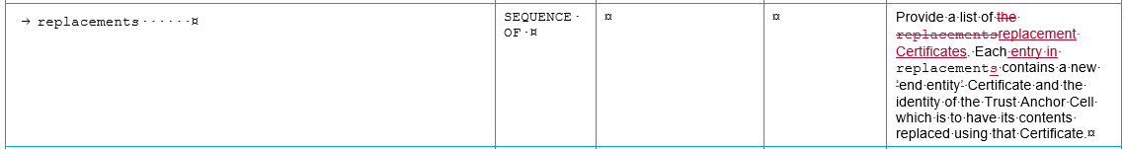
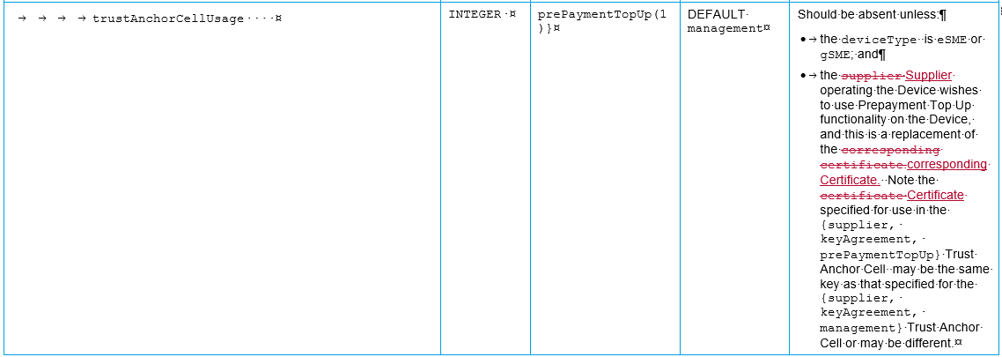
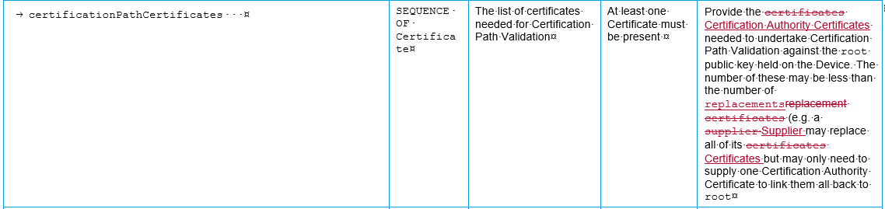

- At GBCS Section 13.3.5.9 make the changes shown in the mark-up below:
<run on as is…>

TS version for incorporation | TBC
Impact on previous RPs | None
Attachment(s) | None
TSIRS view of impact | Consumers: No impact identified
TSIRS view of impact | DCC Users: No impact identified
TSIRS view of impact | DCC & Testing: No impact identified
TSIRS view of impact | Non-SMETS functionality in installed devices: No impact identified

